David Thomsen

CSI-300

Reading Links:

* [Churcher](https://learning-oreilly-com.cobalt.champlain.edu/library/view/beginning-database-design/9781430242093/9781430242093_Ch04.xhtml#head3)

Assignment:

* Churcher Exercise 4-3 p 58
* Churcher Exercise 5-2 p 74
* Churcher Exercise 7-1 p 111

Sources:

* Worked alongside Micah Kezar

**Exercise 4-3**

**Part of the data model about guests at a hostel is shown in Figure 4-25. How could the model be amended to keep historical information about room occupancy?**

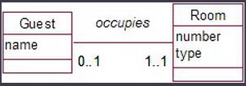

One way that this could be amended is with a GuestHistory table that explains the status of the guest, rather than just having a Guest-Room relationship. For example, if someone calls ahead in advance to book a room, or see a room’s availability, the customer history will note this interaction and the room can be assigned to the guest temporarily, or the managers can wait until payment is received to give the guest the room. Keeping payment history or even just customer history can also be an important security measure as there could be repeat issues with a guest and that can be noted in their history.

**Exercise 5-2**

**A university wants to model information about the teaching of courses. A number of staff members may contribute to providing lectures, and one staff member is denoted as the course supervisor. Suggest an initial data model.**

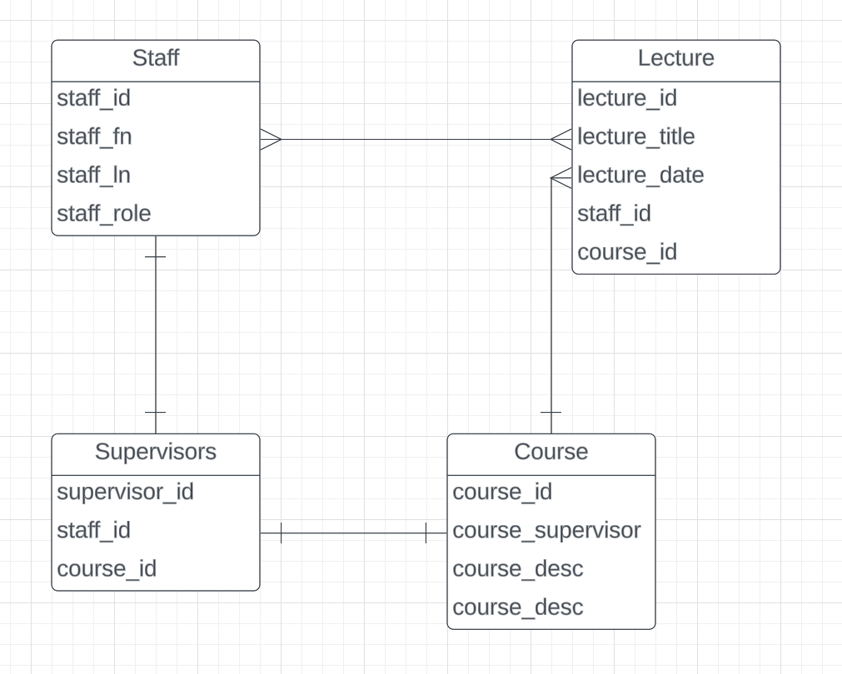

Here is an example of an initial data model. The tables include staff, Lectures, and courses. Multiple members of staff can give many lectures, and there can be multiple lectures within a course, but the course only has one supervisor denoted by supervisors table.

**Exercise 7-1**

**Figure 7-25 shows an initial data model for a small library. It is incomplete, so as you answer the questions below consider what else might need to be included.**

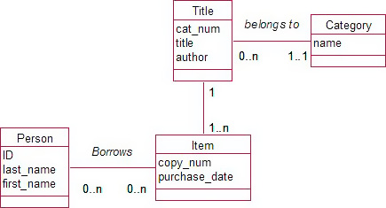

**a) Explain to the librarian what the initial data model means.**

The initial data model explains the relationship between people, items in the library, and the information about the items within the library. For the people, it lists their ID number, their name, as well as their relationship (Borrowing) to the items in the library. The information that is being collected about the Item is just the copy number as well as the date it was purchased. Every item in the library has one title and the information gathered in that table is the cat number, the title, and the author. Now that each Item has a title, it also belongs to a certain category whether the item borrowed was an audiobook, CD, physical book, movie, etc. That is what information the category table holds.

**b) Design tables for a relational database which would capture the information represented by the model. Include primary and foreign keys and other appropriate constraints.**

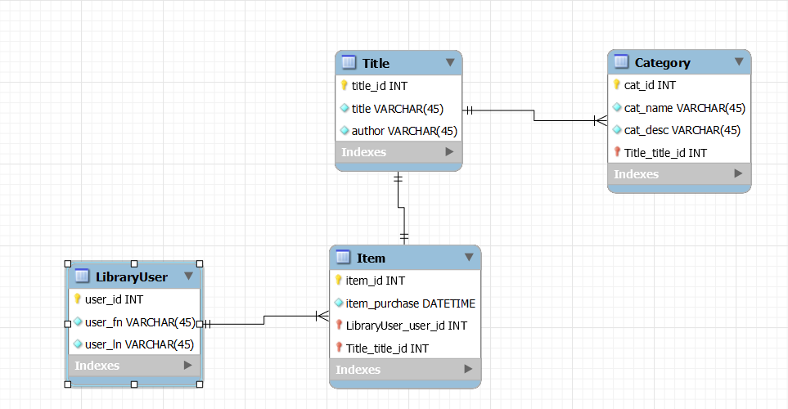

**Additional Questions:**

4. Describe the difference between one-one, one-many, and many-many

Relationships.

**One-one** - This is a direct one to one relationship where one item from one table equates to only one other item on the table.

i.e. One Employee can only have one ID number, and no other Employee can share it.

**One-many** - This is a one to many relationship where one item from one item can have multiple relationships with another table, but it only goes one way.

i.e. One dog may have many fleas, but all the fleas only have the one dog.

**Many-many** - This is a many to many relationship where many items can have multiple relationships with another table.

i.e Many players can play many games and many games can be played by many players.

5. Create a database called “dogs” with a table called “breeds.” The breeds table

should contain the columns “name”, “lifespan”, and “avgweight”. Please note

that “avgweight” should be in pounds.

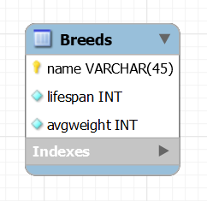

Add at least 3 rows to the table. Write a query that will delete all breeds with a

lifespan < 10 years. Include all of your queries as your answer for question 5.

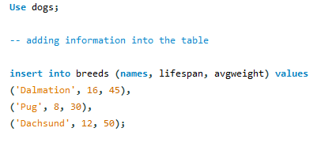

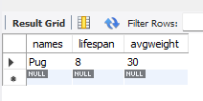

6. Write a query that converts the “avgweight” column from pounds to kilograms.

Alter the table to contain “avgweightlbs” and “avgweightkgs” column. Include

all of your queries as your answer for this question.

